

**CSEE-5110 0002, Fall 2016**

**Network Architecture**

**Project:** Socket Programming ‘Proxy Web-Server’ using Python

**Instructor:** Dr. Ken Mitchell

**Submitted by:**

* Ghosh Sovan
* Tarafdar Rajarshi
* Colaso Plamond
* Singh Harmeet
* Kapoor Adhirath

Sockets are endpoints which connect the client and the server together which a peer to peer connection. Proxy Web Server is typically thought of as a long-running program that sends network messages only in response coming from the network. The other side of the protocol is a web client such as a browser, which always initiates communication with the server. The main function of proxy server is that if the page is loaded in the server cache it will send it to client else it will redirect client to the desired website. The organization into client and server is used by most network – aware applications. Deciding that the client always initiates requests tends to simplify the protocol as well as the programs themselves.

Clients normally communication with one server at a time, although using a web browser we might able to communicate with many different web servers. But from the server’s perspective at any given point in time, is not usual for a server to be communicating with multiple clients.

Internet

Proxy Server IP

10.205.0.179

Client IP

192.168.0.27

We have installed the web server on IP 10.205.0.179 which accepts and parse the HTTP request, get the requested file from the server’s file system, further on sends the response directly to the client on IP 192.168.0.27. When the requested file which is an HTML file is not present in the server, the server redirects the client to desired website.

**Reference:**

We have got the idea of the code from the below website:

http://stackoverflow.com/questions/30109605/http-proxy-server-python

**System Setup:**

Environment: windows 7

Software: python 2.6

Browser: Google Chrome

Language: Python

**Screenshots:**

**Proxy server: umkc.edu**

When we request the website umkc.edu which is not present in the server, server will redirect the client directly to umkc.edu

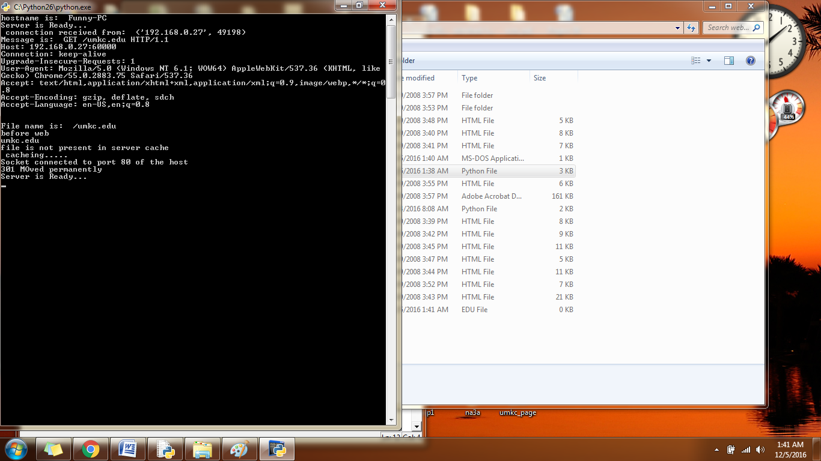

**Output:**

**Proxy server: linkedin.com**

When we request the website linkedin.com which is not present in the server, server will redirect the client directly to linkedin.com

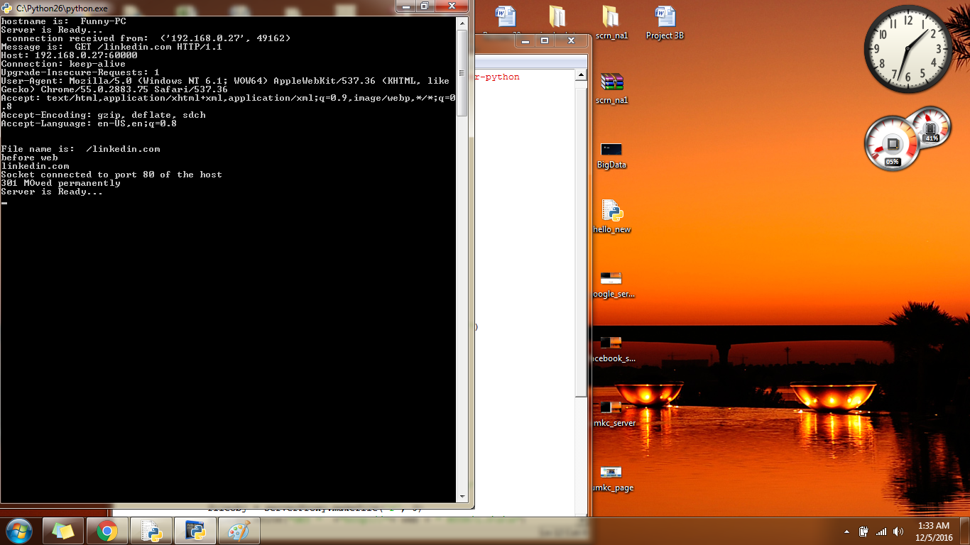

**Output:**

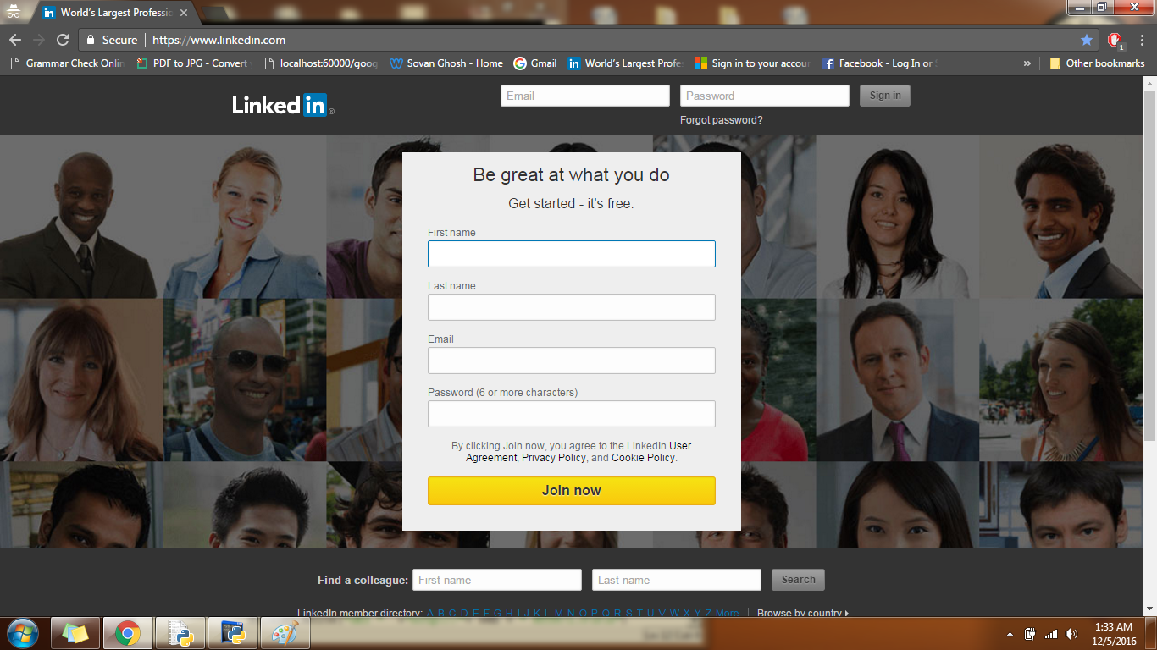

**Academic dishonesty form:**

